CC_LMS_37 — Submit Ratings and Reviews
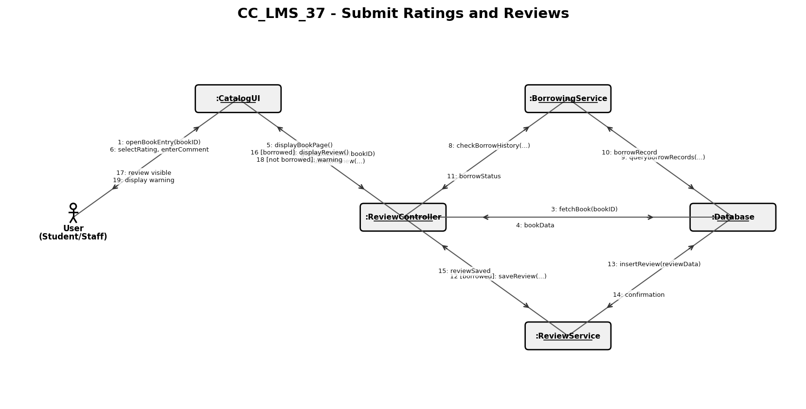

CC_LMS_38 — Provide System Feedback
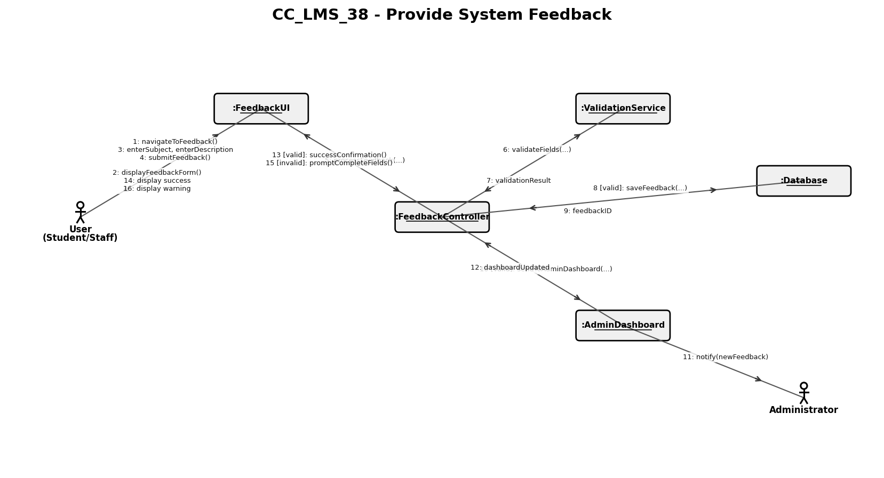

CC_LMS_39 — View Personalized Recommendations
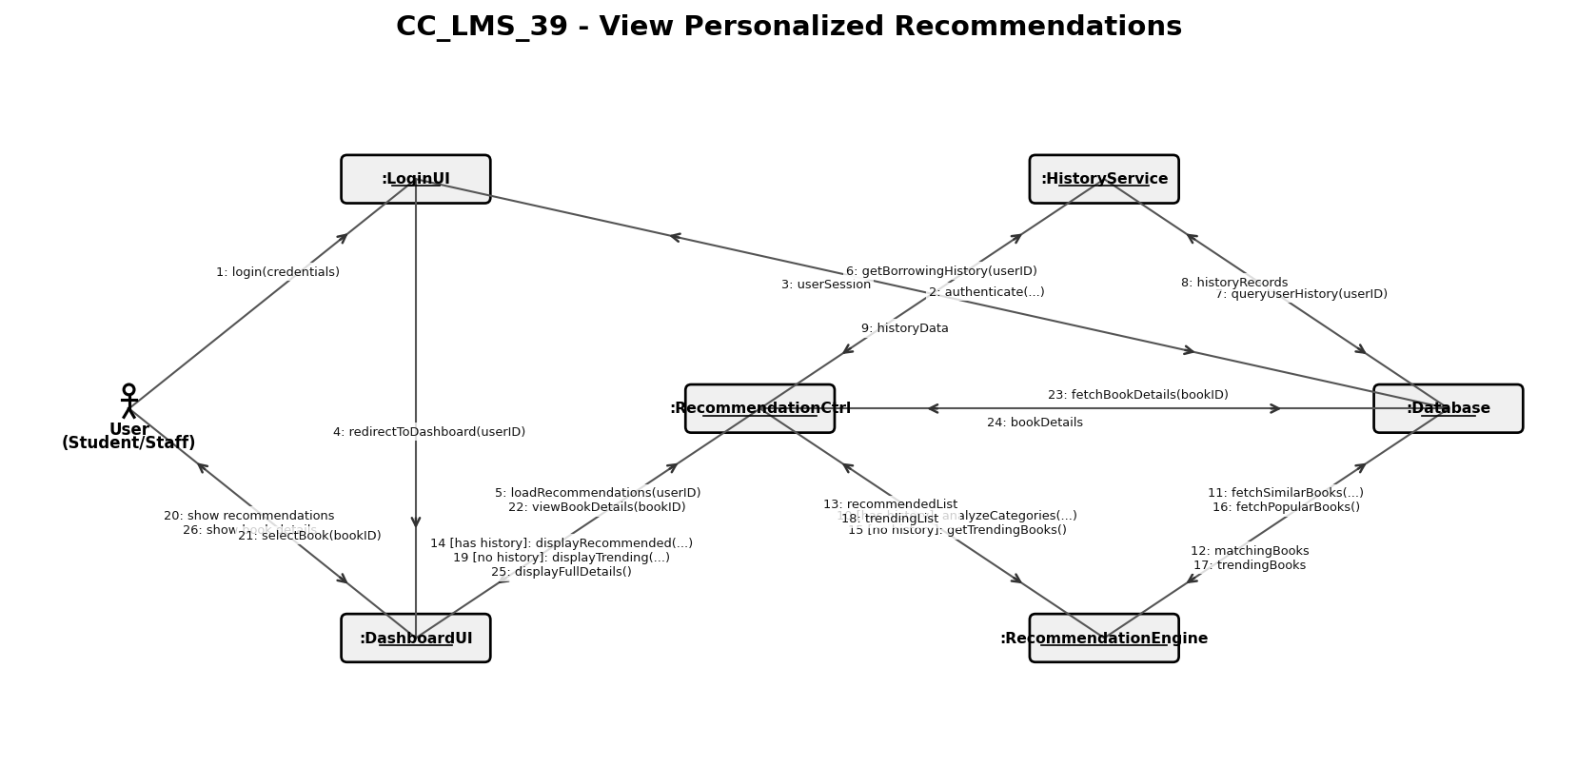

CC_LMS_40 — Manage Personal Wishlist
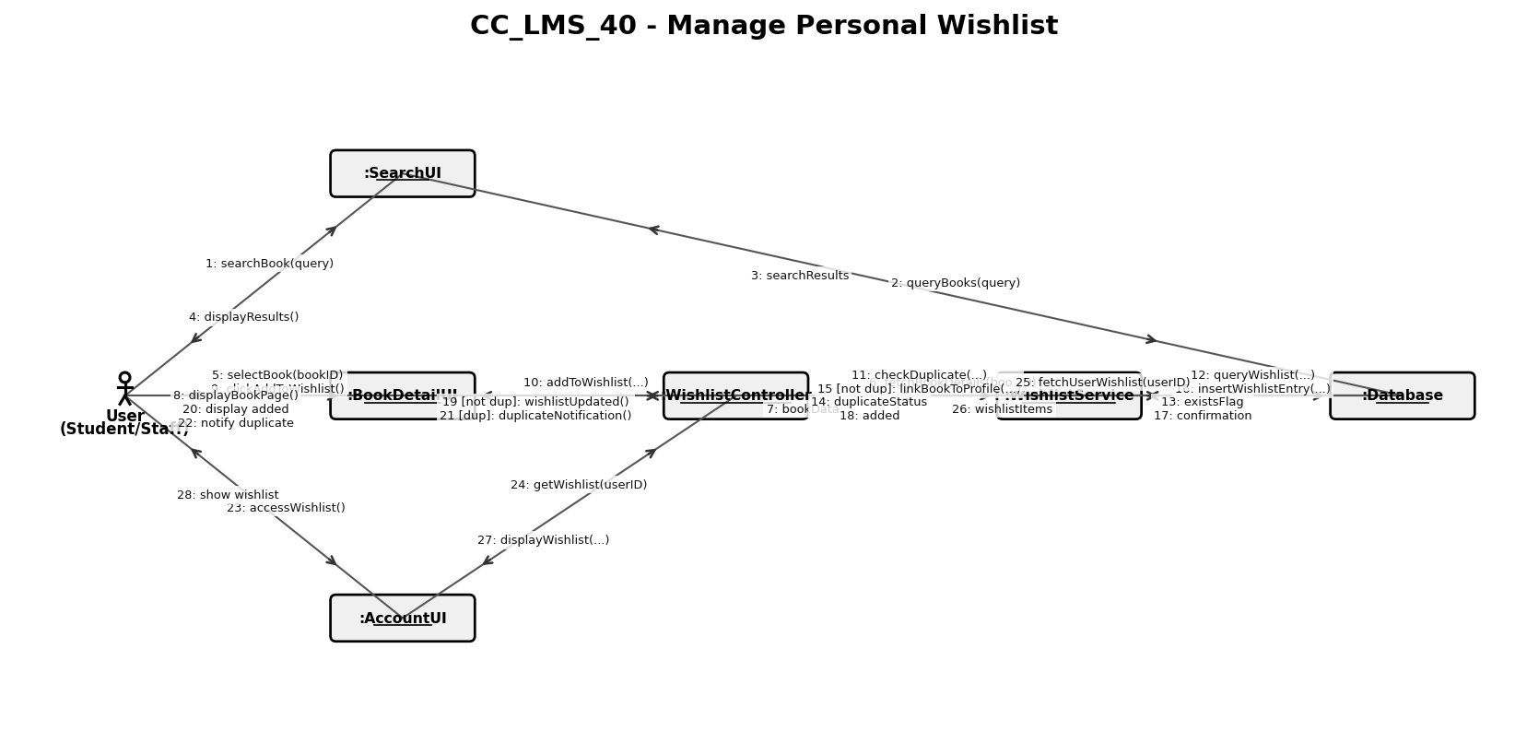

CC_LMS_41 — Respond to User Reviews
